Data and asset classification
Protecting an organization’s business operations and assets from security threats, risks, and vulnerabilities is important. You previously learned what it means to have a security mindset. That mindset can help you identify and reduce security risks and potential incidents.
In this reading, you will learn about key data classification types and the difference between the low-level and high-level assets of an organization.

Classifying for safety
Security professionals classify data types to help them properly protect an organization from cyber attacks that negatively impact business operations. Here is a review of the most common data types:
- Public data
- Private data
- Sensitive data
- Confidential data

Public data
This data classification does not need extra security protections. Public data is already accessible to the public and poses a minimal risk to the organization if viewed or shared by others. Although this data is open to the public, it still needs to be protected from security attacks. Examples of public data include press releases, job descriptions, and marketing materials.

Private data
This data classification type has a higher security level. Private data is information that should be kept from the public. If an individual gains unauthorized access to private data, that event has the potential to pose a serious risk to an organization.
Examples of private data can include company email addresses, employee identification numbers, and an organization’s research data.

Sensitive data
This information must be protected from everyone who does not have authorized access. Unauthorized access to sensitive data can cause significant damage to an organization’s finances and reputation.
Sensitive data includes personally identifiable information (PII), sensitive personally identifiable information (SPII), and protected health information (PHI). Examples of these types of sensitive data are banking account numbers, usernames and passwords, social security numbers (which U.S. citizens use to report their wages to the government), passwords, passport numbers, and medical information.

Confidential data
This data classification type is important for an organization’s ongoing business operations. Confidential data often has limits on the number of people who have access to it. Access to confidential data sometimes involves the signing of non-disclosure agreements (NDAs)— legal contracts that bind two or more parties to protect information—to further protect the confidentiality of the data.
Examples of confidential data include proprietary information such as trade secrets, financial records, and sensitive government data.

Asset classification
Asset classification means labeling assets based on sensitivity and importance to an organization. The classification of an organization's assets ranges from low- to high-level.
Public data is a low-level asset. It is readily available to the public and will not have a negative impact on an organization if compromised. Sensitive data and confidential data are high-level assets. They can have a significantly negative impact on an organization if leaked publicly. That negative impact can lead to the loss of a company’s competitive edge, reputation, and customer trust. A company’s website address is an example of a low-level asset. An internal email from that company discussing trade secrets is an example of a high-level asset.

Key takeaways
Every company has their own data classification policy that identifies what type of data is in each category. It will be important to your success as a security professional to familiarize yourself with that policy. Understanding different data and asset classification types is important. It helps you prioritize what data needs to be protected most. It also helps you recognize what assets need higher levels of security and what assets need minimal security.

Disaster recovery and business continuity
The role of a security professional is to ensure a company’s data and assets are protected from threats, risks, and vulnerabilities. However, sometimes things don’t go as planned. There are times when security incidents happen. You’ve already learned that security breaches can lead to financial consequences and the loss of credibility with customers or other businesses in the industry.
This reading will discuss the need to create business continuity and disaster recovery plans to minimize the impact of a security incident on an organization’s business operations. Analysts need to consider the sequence of steps to be taken by the security team before business continuity and disaster recovery plans are implemented.

Identify and protect
Creating business continuity and disaster recovery plans are the final steps of a four-part process that most security teams go through to help ensure the security of an organization.
First, the security team identifies the assets that must be protected in the organization. Next, they determine what potential threats could negatively impact those assets. After the threats have been determined, the security team implements tools and processes to detect potential threats to assets. Lastly, the IT or appropriate business function creates the business continuity and disaster recovery plans. These plans are created in conjunction with one another. The plans help to minimize the impact of a security incident involving one of the organization’s assets.

Business continuity plan
The impact of successful security attacks on an organization can be significant. Loss of profits and customers are two possible outcomes that organizations never want to happen. A business continuity plan is a document that outlines the procedures to sustain business operations during and after a significant disruption. It is created alongside a disaster recovery plan to minimize the damage of a successful security attack. Here are four essential steps for business continuity plans:
- Conduct a business impact analysis. The business impact analysis step focuses on the possible effects a disruption of business functions can have on an organization.
- Identify, document, and implement steps to recover critical business functions and processes. This step helps the business continuity team create actionable steps toward responding to a security event.
- Organize a business continuity team. This step brings various members of the organization together to help execute the business continuity plan, if it is needed. The members of this team are typically from the cybersecurity, IT, HR, communications, and operations departments.
- Conduct training for the business continuity team. The team considers different risk scenarios and prepares for security threats during these training exercises.

Disaster recovery plan
A disaster recovery plan allows an organization’s security team to outline the steps needed to minimize the impact of a security incident, such as a successful ransomware attack that has stopped the manufacturing team from retrieving certain data. It also helps the security team resolve the security threat. A disaster recovery plan is typically created alongside a business continuity plan. Steps to create a disaster recovery plan should include:
- Implementing recovery strategies to restore software
- Implementing recovery strategies to restore hardware functionality
- Identifying applications and data that might be impacted after a security incident has taken place

Key takeaways
Disaster recovery and business continuity plans are important for an organization’s security posture. It’s essential that the security team has plans in place to keep the organization’s business operations moving forward in case a security incident does occur.

Business continuity plan (BCP): A document that outlines the procedures to sustain business operations during and after a significant disruption
Confidential data: Data that often has limits on the number of people who have access to it
Disaster recovery plan: A plan that allows an organization’s security team to outline the steps needed to minimize the impact of a security incident
Private data: Information that should be kept from the public
Public data: Data that is already accessible to the public and poses a minimal risk to the organization if viewed or shared by others
Security mindset: The ability to evaluate risk and constantly seek out and identify the potential or actual breach of a system, application, or data
Sensitive data: A type of data that includes personally identifiable information (PII), sensitive personally identifiable information (SPII), and protected health information (PHI)

Escalate with a purpose
You previously learned about security incident escalation and the skills needed to help you escalate incidents. In this reading, you’ll learn the importance of escalating security issues and the potential impact of failing to escalate an issue.

Incident escalation
Security incident escalation is the process of identifying a potential security incident. During this process, potential incidents are transferred to a more experienced department or team member. As a security analyst, you’ll be expected to recognize potential issues, such as when an employee excessively enters the wrong credentials to their account, and report it to the appropriate person. When you join a new organization, you’ll learn about the specific processes and procedures for escalating incidents.

Notification of breaches
Many countries have breach notification laws, so it's important to familiarize yourself with the laws applicable in the area your company is operating in. Breach notification laws require companies and government entities to notify individuals of security breaches involving personally identifiable information (PII). PII includes personal identification numbers (e.g., Social Security numbers, driver’s license numbers, etc.), medical records, addresses, and other sensitive customer information. As an entry-level security analyst, you’ll need to be aware of various security laws, especially because they are regularly updated.

Low-level security issues
Low-level security issues are security risks that do not result in the exposure of PII. These issues can include the following and other risks:
- An employee having one failed login attempt on their account
- An employee downloading unapproved software onto their work laptop
These issues are not significant security challenges, but they must be investigated further in case they need to be escalated. An employee typing in a password two to three times might not be of concern. But if that employee types in a password 15 times within 30 minutes, there might be an issue that needs to be escalated. What if the multiple failed login attempts were a malicious actor attempting to compromise an employee’s account? What if an employee downloads an internet game or software on their work laptop that is infected with malware? You previously learned that malware is software designed to harm devices or networks. If malware is downloaded onto an organization’s network, it can lead to financial loss and even loss of reputation with the organization’s customers. While low-level security issues are not considered significant security threats, they should still be investigated to ensure they result in minimal impact to the organization.

The escalation process
Every company has different protocols and procedures, including unique escalation policies. These policies detail who should be notified when a security alert is received and who should be contacted if the first responder is not available. The policy will also determine how someone should specifically escalate an incident, whether it’s via the IT desk, an incident management tool, or direct communication between security team members.

Key takeaways
Incident escalation is essential for protecting an organization’s data. Every organization might have a different way of escalating security incidents. A security analyst should be aware of the escalation protocols that are in place at their organization. Both small and large security issues should be escalated to the appropriate team or team member.

Recognize roles and responsibilities during escalation
You previously learned about various incident classification types and how those incidents can impact an organization.
This reading will discuss the roles of the various team members who are a part of the incident escalation process. Keep in mind that not all organizations are alike, and some roles and responsibilities may be identified using different terminology and definitions.

Data owners
A data owner is the person that decides who can access, edit, use, or destroy their information. Data owners have administrative control over specific information hardware or software and are accountable for the classification, protection, access, and use of company data. For example, consider a situation where an employee gains unauthorized access to software they do not need to use for work. This kind of security event would be escalated to the data owner of that software.

Data controllers
Data controllers determine the procedure and purpose for processing data. This role largely focuses on collecting the personal information of customers. The data controller determines how that data is used. The data controller also ensures that data is used, stored, and processed in accordance with relevant security and privacy regulations. If sensitive customer information was at risk, that event would be escalated to data controllers.

Data processors
Data processors report directly to the data controller and are responsible for processing the data on behalf of the data controller. The data processor is typically a vendor and is often tasked with installing security measures to help protect the data. Data processing issues are typically escalated to the individual who oversees the third-party organization responsible for data processing.

Data custodians
Data custodians assign and remove access to software or hardware. Custodians are responsible for implementing security controls for the data they are responsible for, granting and revoking access to that data, creating policies regarding how that data is stored and transmitted, advising on potential threats to that data, and monitoring the data. Data custodians are notified when data security controls need to be strengthened or have been compromised.

Data protection officers (DPOs)
Data protection officers are responsible for monitoring the internal compliance of an organization’s data protection procedures. These individuals advise the security team on the obligations required by the organization's data protection standards and procedures. They also conduct assessments to determine whether or not the security measures in place are properly protecting the data as necessary. DPOs are notified when set standards or protocols have been violated.

Key takeaways
Incident escalation requires various members of a security team to act as one. Entry-level analysts should be familiar with the roles and responsibilities of different team members on the security team. As an entry-level analyst, you will typically escalate incidents to your direct supervisor. However, it’s still important to have an understanding of the different team members as you move forward in your security career because it will help you recognize which incidents should be reported to whom.

Escalation timing
You previously learned about the potential impact even the smallest incident can have on an organization if the incident is not escalated properly. You also discovered just how important your role as an entry-level analyst will be to the effectiveness of an organization’s escalation process.
This reading will go into more detail about the role you’ll play in protecting an organization’s data and assets when it comes to escalating incidents.

Your decisions matter
Security is a fast-paced environment with bad actors constantly trying to compromise an organization’s systems and data. This means security analysts must be prepared to make daily decisions to help keep a company’s data and systems safe. Entry-level security analysts help the security team escalate potential security incidents to the right team members. A big part of your role as a security analyst will be making decisions about which security events to escalate before they become major security incidents.

Trust your instincts and ask questions
Confidence is an important attribute for a security analyst to have, especially when it comes to the escalation process. The security team will depend on you to be confident in your decision-making. You should be intentional about learning the organization’s escalation policy. This will help you gain confidence in making the right decisions when it comes to escalating security events. But remember to ask questions when necessary. It shows that you’re committed to constantly learning the right way to do your job.

All security events are not equal
An important part of escalation is recognizing which assets and data are the most important for your organization. You can determine this information by reading through your onboarding materials, asking your supervisor directly about which assets and data are most important, and reviewing your company’s security policies. When you have that type of understanding, it allows you to recognize when one incident should be given a higher priority over others. You previously learned about the following incident classification types:
- Malware infections: Occur when malicious software designed to disrupt a system infiltrates an organization’s computers or network
- Unauthorized access: Occurs when an individual gains digital or physical access to a system, data, or application without permission
- Improper usage: Occurs when an employee of an organization violates the organization’s acceptable use policies
Identifying a specific incident type allows you to properly prioritize and quickly escalate those incidents. Remember, an incident which directly impacts assets that are essential to business operations should always take priority over incidents that do not directly impact business operations. For example, an incident where unauthorized access has been gained to a manufacturing application should take priority over an incident where malware has infected a legacy system that does not impact business operations. As you gain experience in the cybersecurity field, you will learn how to quickly assess the priority levels of incident types.

Quick escalation tips
A big part of your role in cybersecurity will be determining when to escalate a security event. Here are a few tips to help with this:
- Familiarize yourself with the escalation policy of the organization you work for.
- Follow the policy at all times.
- Ask questions.

Key takeaways
Incident escalation will be an important part of your role within a security team. Entry-level analysts are expected to identify and escalate incidents related to their daily work. Reading and understanding your organization’s escalation policy will be helpful in this responsibility. The escalation policy will describe how and to whom you should escalate incidents. When in doubt, never be afraid to ask a supervisor about the escalation process. This will help you stay knowledgeable about your job and make informed decisions.

Terms and definitions from Course 8, Module 2
Data controller: A person that determines the procedure and purpose for processing data
Data processor: A person that is responsible for processing data on behalf of the data controller
Data protection officer (DPO): An individual that is responsible for monitoring the compliance of an organization's data protection procedures
Escalation policy: A set of actions that outlines who should be notified when an incident alert occurs and how that incident should be handled
Improper usage: An incident type that occurs when an employee of an organization violates the organization’s acceptable use policies
Incident escalation: The process of identifying a potential security incident, triaging it, and handing it off to a more experienced team member
Malware infection: An incident type that occurs when malicious software designed to disrupt a system infiltrates an organization’s computers or network
Unauthorized access: An incident type that occurs when an individual gains digital or physical access to a system or an application without permission

The purpose and impact of stakeholders
You previously learned about incident escalation and the various security incident classification types. You also learned about the impact these incidents can have on an organization’s business operations.
This reading will explore the individuals who have a significant interest in those business operations: stakeholders.

Who are stakeholders?
A stakeholder is defined as an individual or group that has an interest in any decision or activity of an organization. A big part of what you’ll do as a security analyst is report your findings to various security stakeholders.

Levels of stakeholders
There are many levels of stakeholders within larger organizations. As an entry-level analyst, you might only communicate directly with a few of them. Although you might not communicate with all of the security stakeholders in an organization, it’s important to have an understanding of who key stakeholders are:
- A cybersecurity risk manager is a professional responsible for leading efforts to identify, assess, and mitigate security risks within an organization.
- A Chief Executive Officer, also known as the CEO, is the highest ranking person in an organization. You are unlikely to communicate directly with this stakeholder as an entry-level analyst.
- A Chief Financial Officer, also known as the CFO, is another high-level stakeholder that you’re unlikely to communicate with directly.
- A Chief Information Security Officer, also known as the CISO, is the highest level of security stakeholder. You are also unlikely to communicate directly with this stakeholder as an entry-level analyst.
- An operations manager oversees the day-to-day security operations. These individuals lead teams related to the development and implementation of security strategies that protect an organization from cyber threats.
CFOs and CISOs are focused on the big picture, like the potential financial burden of a security incident, whereas other roles like operations managers are more focused on the impact on day-to-day operations. Although you will rarely interact directly with high-level security stakeholders, it’s still important to recognize their relevance.

Stakeholder communications for entry-level analysts
Two examples of security stakeholders with whom you might regularly communicate are operations managers and risk managers. When you report to these stakeholders, you'll need to clearly communicate the current security issue and its possible causes. The operations managers will then determine next steps and coordinate other team members to remediate or resolve the issue.
For example, you might report multiple failed login attempts by an employee to your operations manager. This stakeholder might contact the employee’s supervisor to ensure the occurrence is a genuine issue of entering the wrong password or determine if the account has been compromised. The stakeholder and supervisor might also need to discuss the consequences for day-to-day operations if genuine failed login attempts can lead to account lockouts that might impact business operations. As an entry-level security analyst, you might play a role in implementing preventative measures once next steps have been determined.

From one stakeholder to the next
Operations managers and risk managers are stakeholders who rely on entry-level analysts and other team members to keep them informed of security events in day-to-day operations. These stakeholders commonly report back to the CISOs and CFOs to give a broader narrative of the organization's overall security picture. Although you won't regularly communicate with high-level stakeholders, it's important to recognize that your efforts still reach the highest levels of security stakeholders in the organization. These other members of your team keep those top-level stakeholders informed on the security measures and protocols in place that are continuously helping to protect the organization.

Key takeaways
Stakeholders play a major role in ensuring the security of an organization. Entry-level analysts should have a foundational understanding of the different levels of security stakeholders within an organization. Entry-level analysts will not communicate with every security stakeholder in a company, but there are certain stakeholders that the analyst will need to provide updates to. Those updates will eventually be reported up to the more senior-level stakeholders, such as the CISO and the CFO.
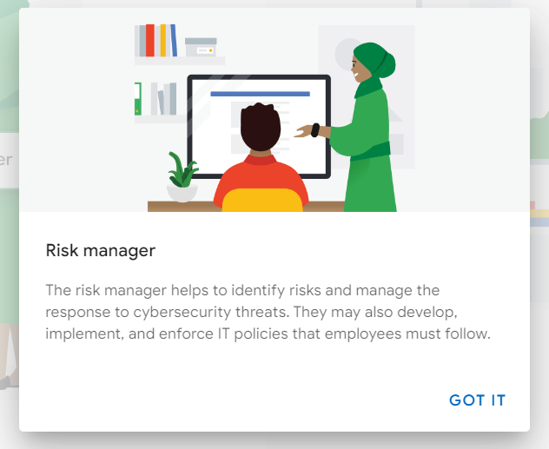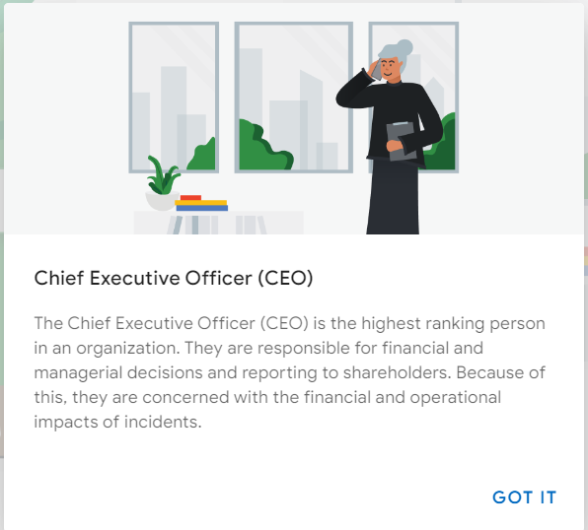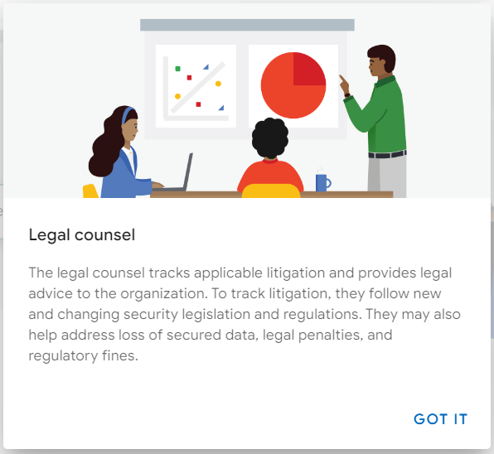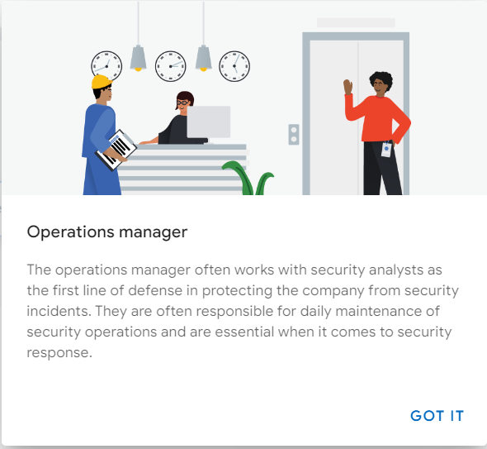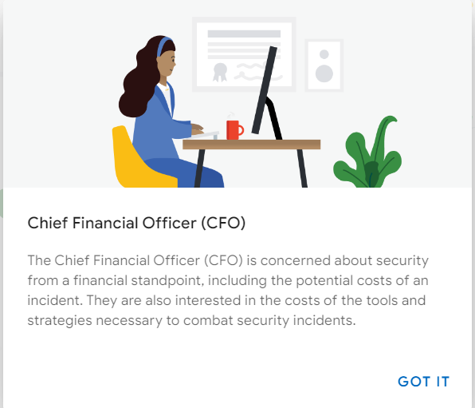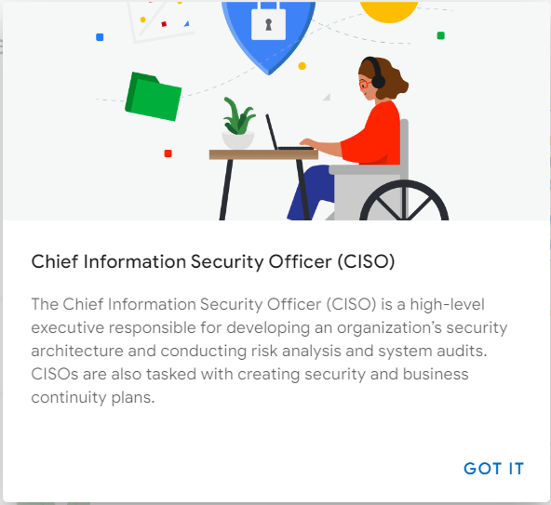

Communicate effectively with stakeholders
You previously learned about security stakeholders and their significance in an organization. In this reading, you’ll learn the importance of clearly communicating to stakeholders to ensure they have a thorough understanding of the information you’re sharing and why it’s meaningful to the organization.

Get to the point
Security stakeholders have roles and responsibilities that are time sensitive and impact the business. It’s important that any communications they receive, and the actions they need to take, are clear. To get to the point in your communications, ask yourself:
- What do I want this person to know?
- Why is it important for them to know it?
- When do they need to take action?
- How do I explain the situation in a nontechnical manner?

Follow the protocols
When you first join a security team, you’ll want to learn about the different protocols and procedures in place for communicating with stakeholders and other members of the organization. It’s important to make sure you know what applications and forms of communications are acceptable before you begin communicating with stakeholders, such as in-person meetings, video-conferencing, emails, or company chat applications.

Communicate with impact
You previously learned about the different stakeholders within an organization and what specific areas they’re focused on. When you first begin your career in the cybersecurity field, you're more likely to interact with lower-level stakeholders, like operations managers or security risk managers, who are interested in the day-to-day operations, such as logging. Senior-level stakeholders might be more interested in the underlying risks, such as the potential financial burden of a security incident—as opposed to the details around logs.
When you communicate with an operations manager, make sure you address relevant information that relates to their daily responsibilities, such as anomalies in data logs that you are escalating. Concentrating on a manager’s daily responsibilities will help you communicate the need-to-know information to that individual.

Communication methods
Your method of communication will vary, depending on the type of information you’re sharing. Knowing which communication channels are appropriate for different scenarios is a great skill to help you communicate effectively with stakeholders. Here are a few ways you might choose to communicate:
- Instant messaging
- Emailing
- Video calling
- Phone calls
- Sharing a spreadsheet of data
- Sharing a slideshow presentation
If your message is straightforward, an instant message or phone call might be the route to take. If you have to describe a complex situation with multiple layers, an email or in-person meeting might be the better option. If you’re providing a lot of data and numbers, sharing a graph might be the best solution. Each situation helps you determine the best means of communication.

Key takeaways
Stakeholders are busy people who have very specific interests within the organization. Therefore, it’s important to only communicate information that is specific to their interests and impacts their role in the company.
Be mindful of the kind of information you’re communicating because that will help determine what method of communication you should use.

Create visual dashboards for impactful cybersecurity communications
You previously learned about security stakeholders, the people responsible for protecting the data and systems of various departments of an organization. An entry-level analyst might communicate directly or indirectly with these individuals. If you do end up communicating with a stakeholder, it’s important to use the right method of communication. This reading will further elaborate on the significance of using visual dashboards to communicate information to stakeholders. Dashboards can include charts, graphs, and even infographics. You’ll learn more about when to use visual communication strategies in this reading.

Using visuals to communicate effectively
Security is about protecting a company from threats that can affect its reputation and finances. Oftentimes, responding to threats quickly and effectively depends on clear communications between the stakeholders who are involved.
In the cybersecurity field, the stakeholders you'll deal with will often be busy with other responsibilities. Showing them important information visually is a great way to gain their input and support to address security challenges that arise. Visuals help provide these decision-makers with actionable information that can help them identify potential risks to the organization's security posture.

Visual dashboards
A visual dashboard is a way of displaying various types of data quickly in one place. Visual dashboards are useful tools that can be used to communicate stories to stakeholders about security events—especially when they involve numbers and data.
Dashboards can be simple or complex depending on the information you're communicating. A simple dashboard might contain a single chart, while a complex one can include multiple detailed charts, graphs, and tables. Deciding which type to use will depend on the situation and story you are telling. However, attention to detail and accurately representing information is important anytime you're communicating data to stakeholders.
Pro tip: Programs like Google Sheets and Apache OpenOffice are tools that can be used to create visual dashboards.

When to use visual communication
Security is often a team effort. Everyone must work together to ensure an organization is properly protected from bad actors. Knowing how to communicate with your colleagues is a big part of the team-focused aspect.
Sometimes it’s enough to send a simple email update. Other times you might want to include a document attachment that further elaborates on a specific topic. A simple phone call can also be valuable because it allows you to quickly communicate the necessary information without having to wait for a response to an email or message. Other times, the best way to communicate is through visuals.
For example, consider a situation where your supervisor has asked you to provide them with results from a recent internal audit of five different departments within the organization. The audit gathered data showing how many phishing emails each department clicked over the last five months. This is an ideal opportunity to tell this story using visualization tools. Instead of sending an email that simply describes what the findings are, a graph or chart will clearly illustrate those findings, making them easier for the stakeholder to understand quickly and easily.

Key takeaways
Stakeholders, like the rest of the security team, are busy. With that in mind, be clear and concise any time you communicate with them. This makes everyone’s job easier! It’s important to recognize when visual dashboards are the most effective communication method. A visual dashboard is often best to use when you’re communicating information that involves numbers and data.

Juliana’s story: Effective communication
Throughout this course, you’ve been following the story of Juliana Soto. Juliana was recently hired as a cybersecurity analyst by Right-On-Time Payment Solutions, a payment processing company that handles sensitive customer information. In the reading about attention to detail, Juliana had to deal with two different types of security incidents, and she used her company’s escalation policy to properly escalate the two incidents. Now you will review how Juliana handled communication with stakeholders after escalating the incidents.

Communicating with stakeholders after an incident
Days after escalating the two incidents, Juliana’s manager asks her to communicate information about the incidents to stakeholders.

Communicating about incident #1
One of the incidents dealt with an employee being locked out of their account due to multiple failed login attempts. Juliana’s manager was recently asked to provide a report that reviews how many departments have experienced locked employee accounts due to failed login attempts over the last month. The security team shared data that details the number of locked employee accounts due to multiple failed login attempts from five different departments.
Juliana’s manager will report the information to the senior executives of each of the five departments. The manager asks Juliana to display the data in a way that communicates the incident clearly to these stakeholders. For this task, Juliana decides to put together a visual dashboard to represent the data because the communication is primarily focused on numbers. Her dashboard will use charts and graphs to relay important information, like the number of employees who have been locked out of their accounts in the last month. Juliana's visual dashboard makes it easier for the high-level stakeholders to review incident #1 and determine a course of action.

Communicating about incident #2
Juliana’s manager has also been informed that the Chief Information Security Officer (CISO) wants more information about what took place during the second incident, which involved an attacker almost compromising a system that stores customers’ private data. This communication will include a more detailed report that establishes what processes and procedures worked well during attackers' attempts to compromise the system and what processes and procedures might need to be revised. Because this is a more detailed communication, Juliana decides to put together a detailed document with timelines that clearly explain what happened. The document also includes her thoughts on what the security team, data owners, and data processors could have done differently to protect the system in question. She shares the report with her manager so they can review it.

Key takeaways
Communications for stakeholders should always be focused on what matters to them most. Some stakeholders will be more focused on the data and numbers, and other stakeholders will be more focused on how policies and procedures are working to prevent cyber attacks. Recognizing what’s important to each stakeholder will help an analyst decide what method of communication is best to use.

Strategies for engaging with the cybersecurity community
You have learned a lot about the security field, from the origins of security and its importance to organizations around the world to recognizing security incidents and communicating with stakeholders.
Security is a rapidly evolving industry, so it’s important to stay up-to-date on the latest news and trends. This reading will focus on how to stay engaged with the cybersecurity community after completing this program.

Security organizations and conferences
Attending security conferences and joining organizations gives you the opportunity to gain knowledge from seasoned professionals who are constantly seeking out new ways to improve on their security strategies and techniques.
Find the right organization
What security organization should you join? This question depends on your specific interest in security. Are you someone who wants to focus on reacting to security incidents or preventing them from happening? Are you interested in forensic security or data logging? Do you have aspirations of being a CISO one day? It’s important to have a clear understanding of what your interests are before you narrow down your search for a cybersecurity organization or conference.
Begin the search
Once you understand what your interests are, do a web search for organizations or conferences in your area. For example, you can type in “incident response cybersecurity conferences in my area.” This search will give you a list of cybersecurity conferences focused on incident response. If you’re interested in forensic security, you can type “forensic security organizations in my area” or a similar phrase into your web search engine. No matter what your interests are, you can do a web search online to find a cybersecurity organization or conference focused on that area.

Use social media
Social media is another great way to find cybersecurity organizations or conferences. LinkedIn®, for example, is a social media platform that connects business professionals with one another. You can use LinkedIn® to find security groups or organizations to join. In the LinkedIn® search bar, you can try search queries such as:
- “Incident response cybersecurity groups”
- “Organizations for cybersecurity analysts”
Be aware of social engineering
While social media is a good way to connect with other professionals in the security industry, it’s also important to be mindful that hackers use social media to trick users into giving up private information. You've previously learned that social engineering is a manipulation technique that exploits human error to gain private information, access, or valuables. To protect yourself from social engineering when using social media to find resources, always remember not to click on unexpected links or attachments sent from unfamiliar users on social media.

Mailing lists for security
Another great way to stay connected with the security industry is to sign up for different cybersecurity mailing lists. These mailing lists send out information periodically on various security topics. The Cybersecurity & Infrastructure Security Agency (CISA) offers two cybersecurity mailing lists for you to join:
- A list focused on security threat information, best practices for cybersecurity, and analysis from CISA’s domestic and international security partners
- A list providing weekly summaries of new vulnerabilities that might pose a risk to an organization’s network

Key takeaways
Attackers are always developing new ways to compromise corporate and personal data from users. Cybersecurity organizations and conferences are a great way for security professionals to stay up-to-date on the latest news, tools, and trends in the industry. Be sure to find organizations that align with your security interests.

Preparation of interview.

Apply the STAR method during interviews
You’ve been learning about different techniques and strategies to use during future interviews for jobs in the cybersecurity field. In this reading, you’ll learn more details about the STAR method for answering interview questions. Implementing this strategy will help you answer interview questions with confidence and clarity.

The STAR method
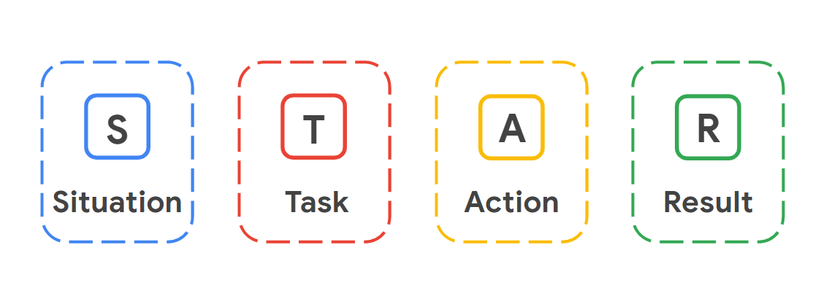
When interviewing for a job, it can be challenging to convey the right details about your professional history and skills to your interviewers. Using the STAR method can help you share your success stories effectively and strategically. STAR stands for Situation, Task, Action, and Result. Using this method enables you to describe potential challenges you faced in previous roles and gives you the opportunity to show how you thoughtfully approached solving those problems from start to finish.

Situation
The situation is the project you worked on or a challenge that you had to overcome. For example, perhaps you had to manage a disgruntled customer’s negative feedback about your company, a system error on your work device that slowed down a customer transaction, or being left alone in the office for an extended period of time. Fully describing the situation allows the interviewer to gain a clear understanding of the challenge you had to overcome.

Task
The task outlines the key responsibilities or role you played in solving the challenge described in the situation phase of the STAR method. Specifying what the task is provides clarity about what your objectives were in this scenario.

Action
The action describes the exact steps you took to resolve the challenging situation you described in the beginning of the STAR method. The action is crucial to the STAR method because it allows the employer to understand what choices you made to achieve your desired outcome during a real conflict or challenge. Employers want employees who can think fast and make decisions that help solve problems.

Result
Finally, sharing the result of your challenge or example shows the employers how the situation was resolved as a direct result of the actions you took. When participating in an interview, you want to make sure that any example you give with the STAR method ends in a positive result. Positive results show an employer that you are someone who has demonstrated an ability to successfully resolve issues and may lead an employer to offer you a job. Of course, not all situations have completely positive outcomes; if an employer asks you about a situation that didn’t have a positive outcome, try to focus on what you learned from the situation and how that experience helped you become a better employee.

Key takeaways
The STAR method stands for Situation, Task, Action, and Result. Following this method helps you communicate to an employer an example of a challenge you faced in the workplace. Remember to use one of your success stories when using the STAR method on an interview. Challenges arise all the time in the security world, so being able to demonstrate an ability to overcome any type of challenge is a great trait to show off during an interview. Plus, since cybersecurity is such a team-driven industry, being able to communicate effectively to an interviewer will help you be a competitive applicant.

